 Gun Club is a non-violent arcade shooter for the PlayStataion®2 computer entertainment system. This non-violent target shooter allows gamers to enter the shooting range, steady their nerves, and take aim at the bull’s-eye. Experience the traditional 1st person shooter from a different perspective; Gun Club is void of blood and violence.
The game puts over one hundred faithfully recreated firearms in the hands of the player who can try his or her skill in a wide range of immersive 3D practice environments, from indoor ranges with paper bull’s eyes, to hillsides with targets or flying sporting clays. A certification mode challenges would-be sharpshooters’ skills, and detailed descriptions and information for every firearm make it a must-have for gun collectors and enthusiasts.
Release Date  Platforms  ESRB  Genre  Publisher:  Number of Players:  UCP Code PS2  Price Point | 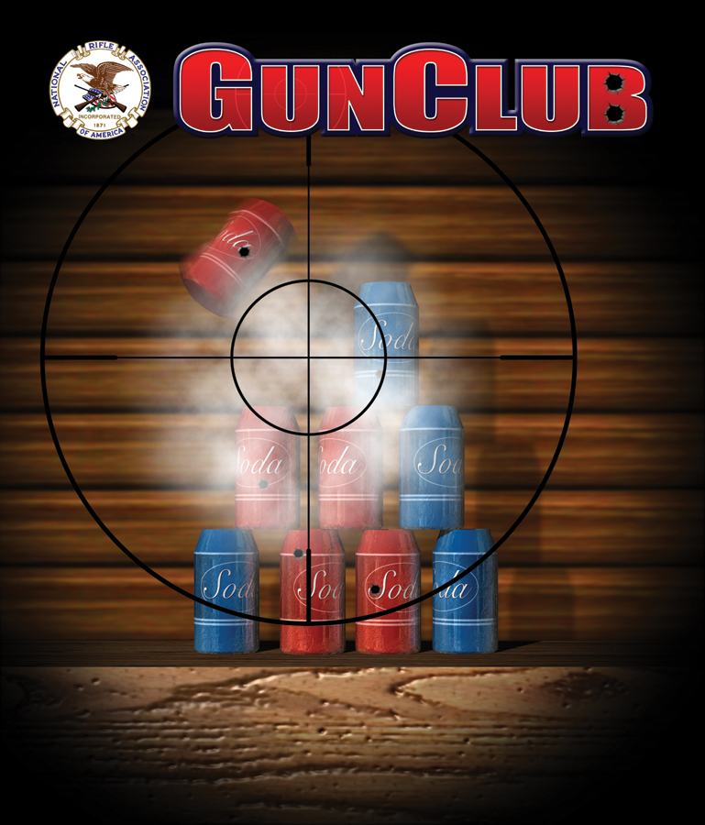  Late Summer 2006 (Q3)  PlayStation®2  “RP”  Arcade Shooter  Crave Entertainment  1 – 8 Players  6-50008-39954-7  $19.99
Why to Buy PS2 | - Over 100 firearms to choose from – current consumer models, LE/military & specialty models  - Detailed descriptions and other details for every firearm  - Quick Match Mode  - Allows players to pickup and play  - Choose from over 15 realistic shooting challenges  - Play with any unlocked weapons in any unlocked environment  - Head-to-head challenges offer competitive gameplay for 1-8 players  - Certification Mode  - 8-stage Certification program allows players to learn how to properly use the various firearms in the product  - 4 classes of firearms, each with various levels of Certification  - Unlock new guns, environments, and challenges by progressing through the program  - Turn-based gameplay for 1-8 players  - 10-12 unique gameplay settings – from close-range shooting galleries to expansive open terrain for long-range targeting  - Focus on firearms with no blood and no violence

